dFaculty of Computer Technology and Cybersecurity
Department of Computer Engineering
ARCHITECTURE AND ORGANIZATION OF COMPUTER SYSTEMS
LABORATORY WORK - 5

Date: 27.09.2026
Full Name: Daniil Kalts
Group: IT2-2404SE

PROGRESS OF WORK
1) Start the Microchip Studio.
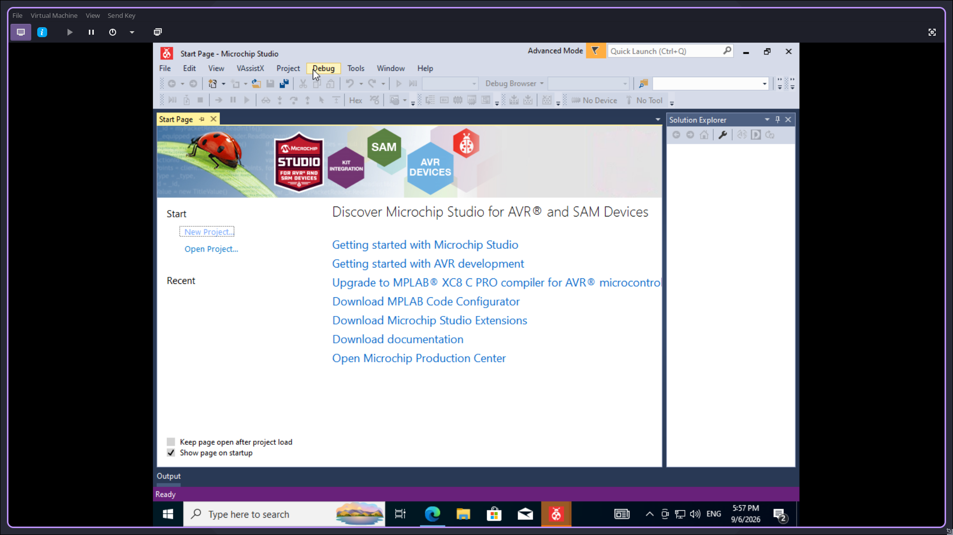

2) Create a new GCC C Executable project.
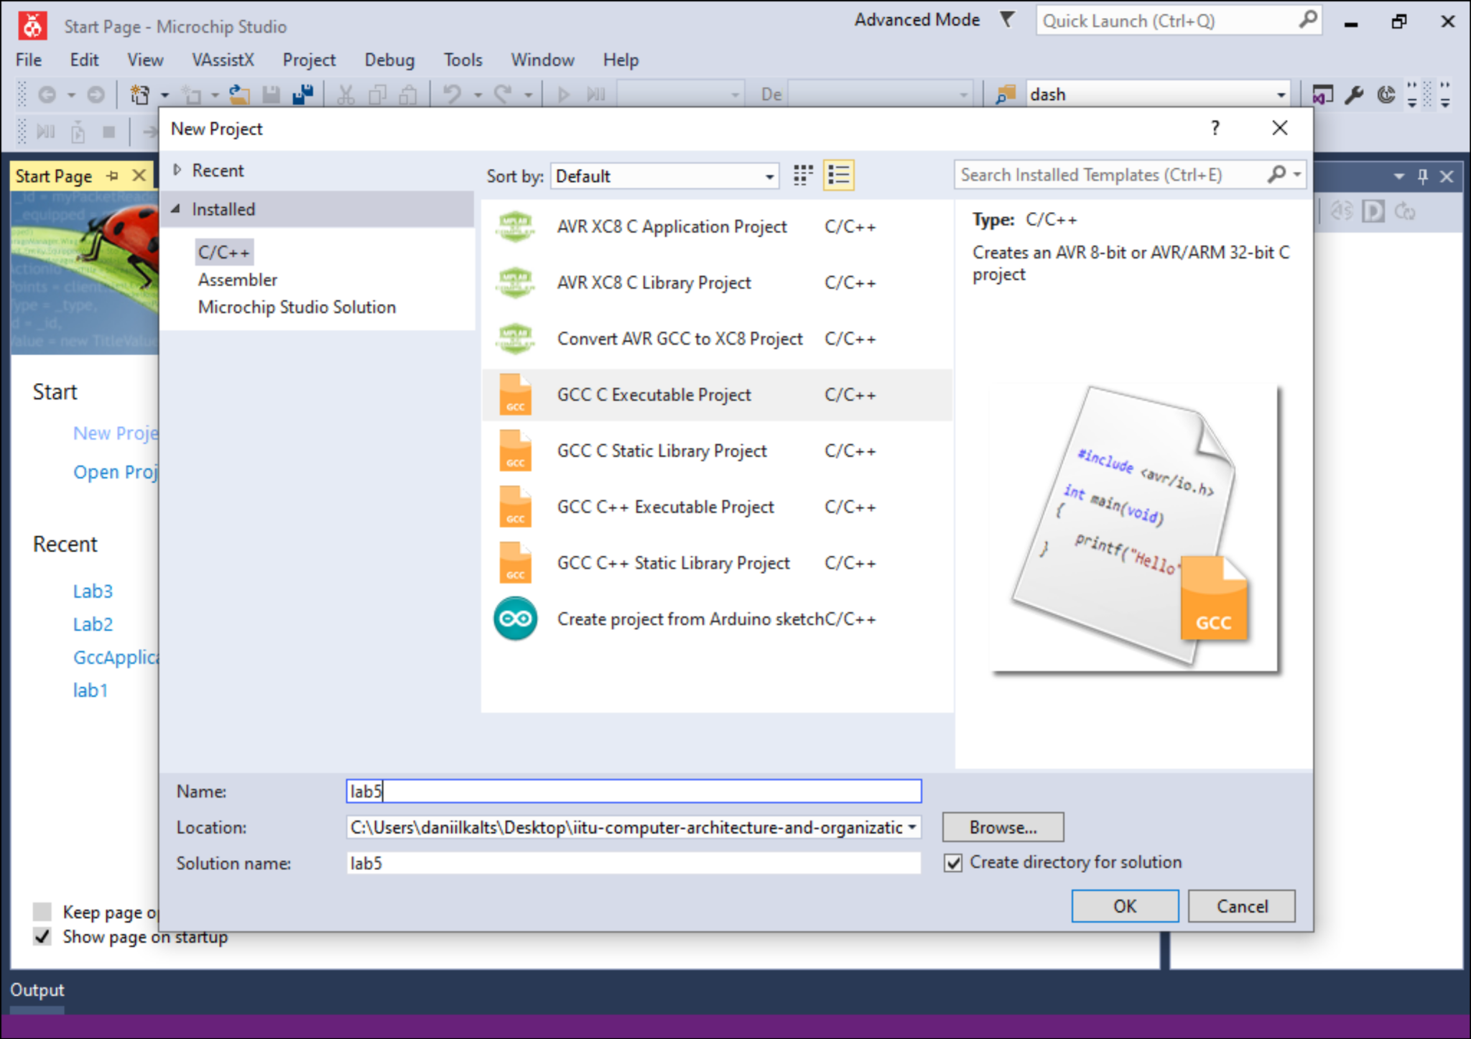
3) Select the device (in this work — ATmega2561).
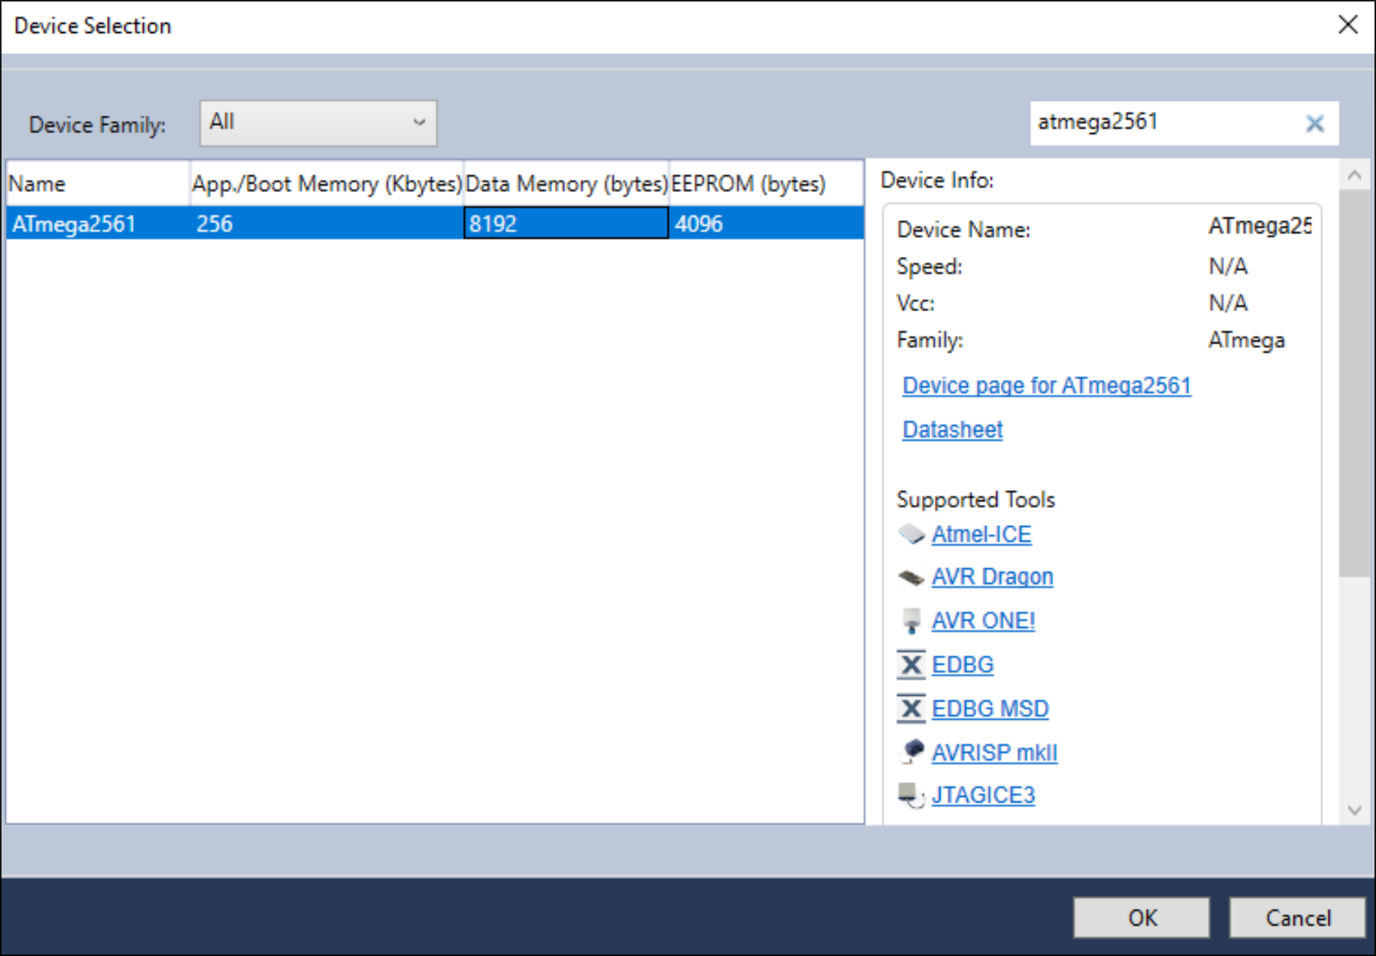

4) Next, program the microcontroller.
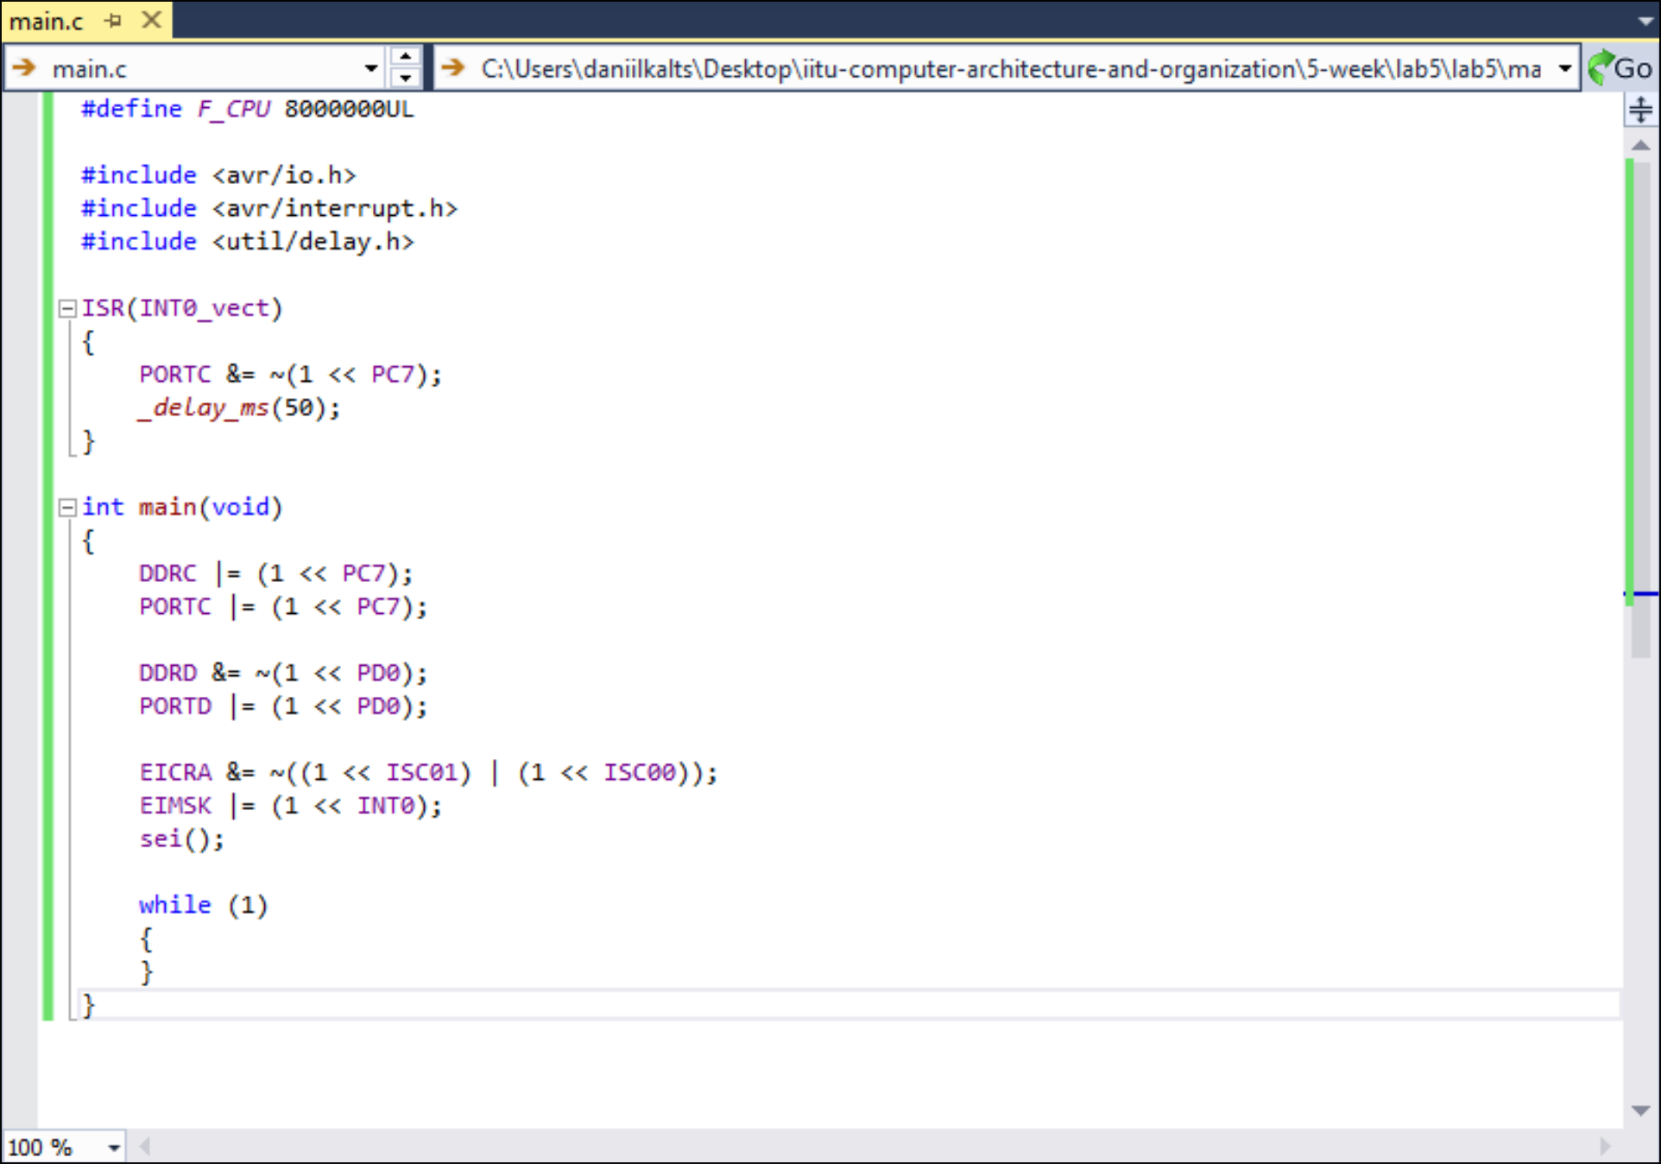
5. Compile the project and obtain the .hex file.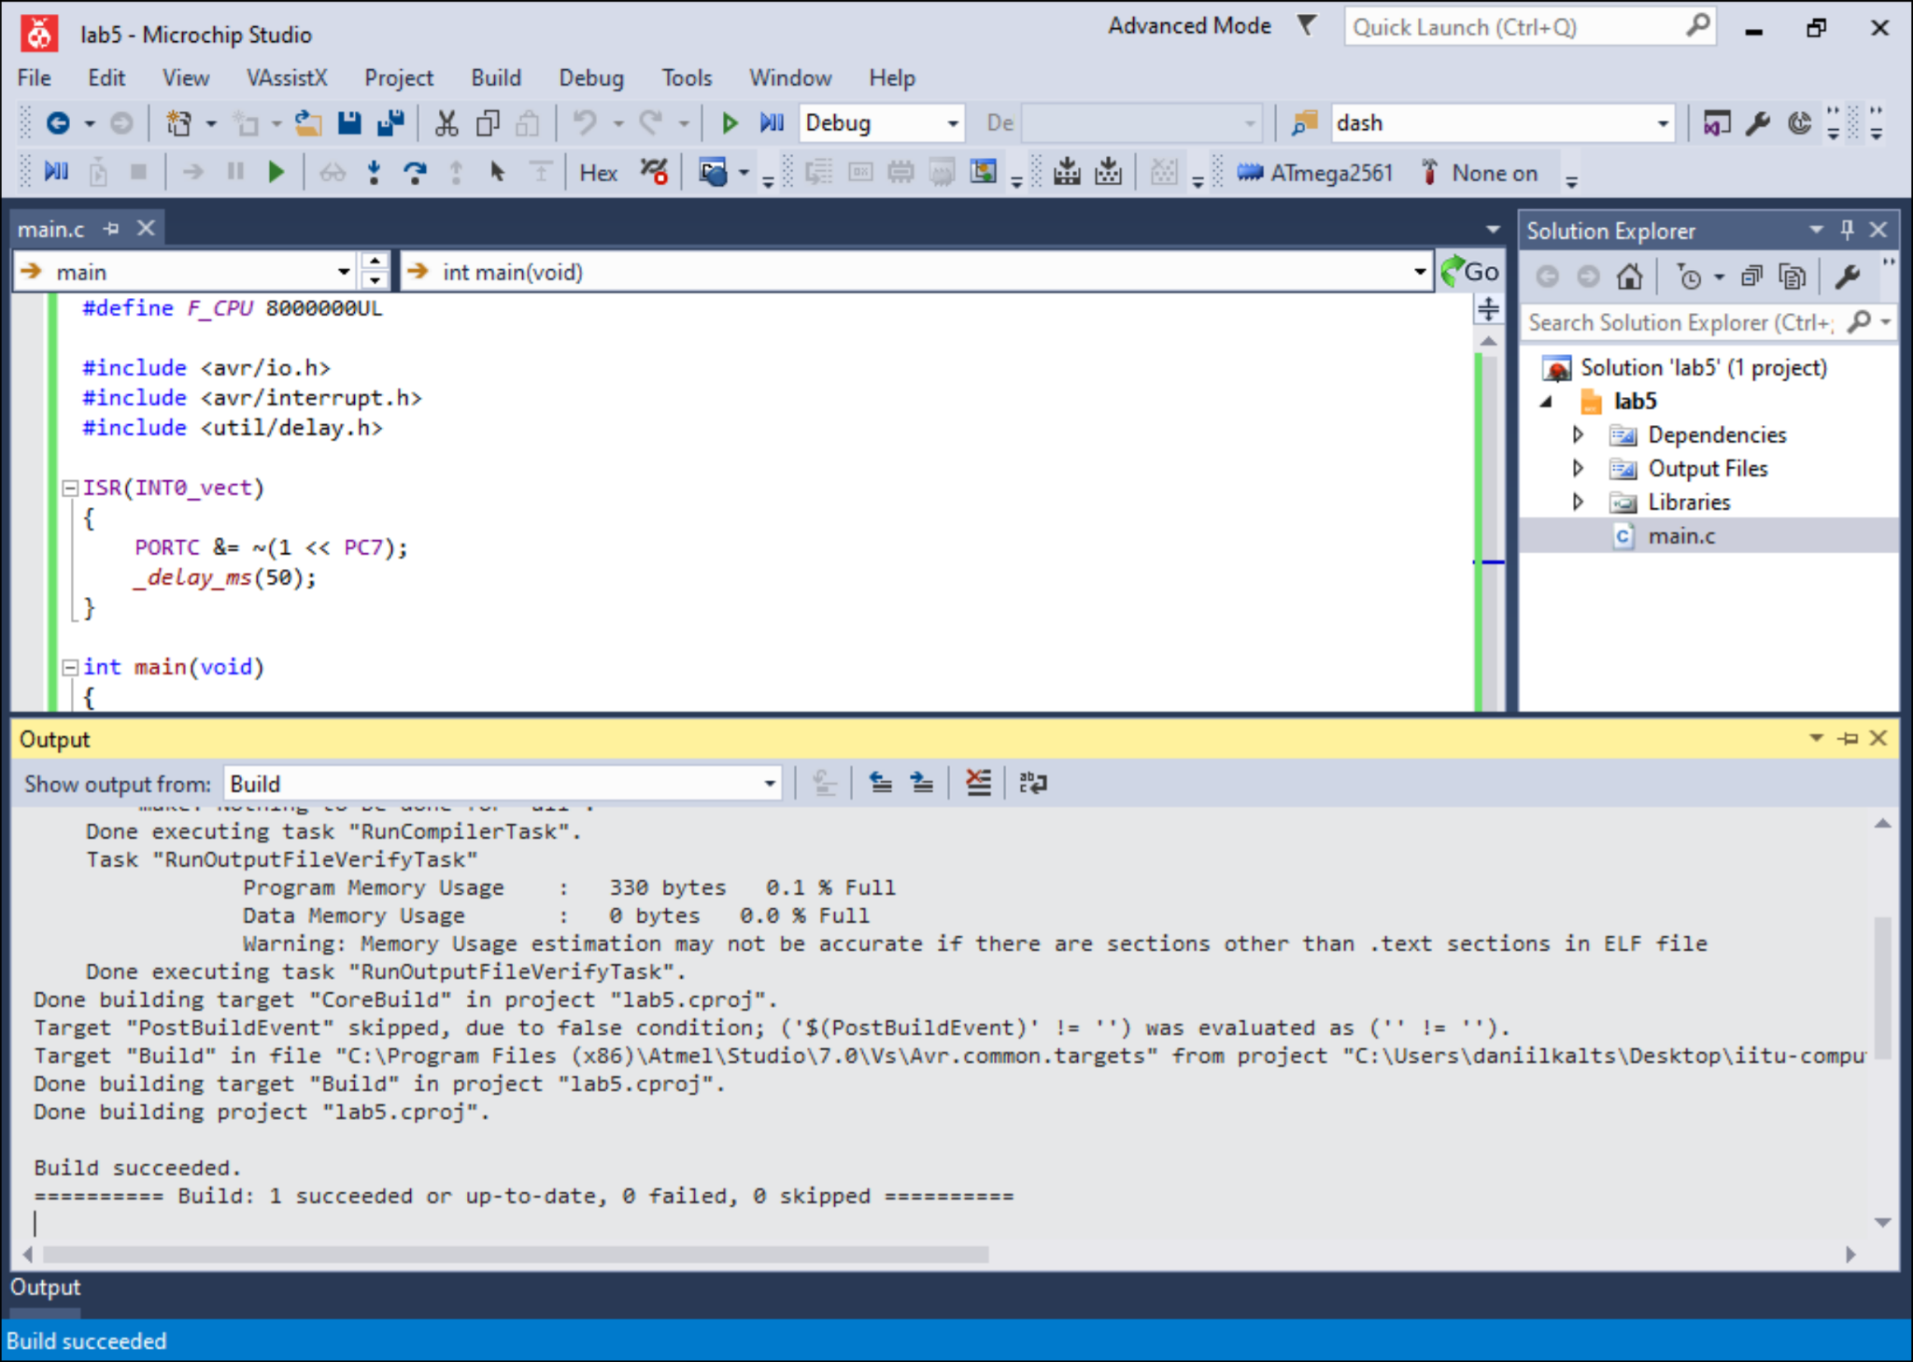
6. Add the ATmega2561, one push button, one LED, a 750 Ω resistor, VCC, and GND to the schematic. Connect the button to PD0/INT0 and the LED to PC7.

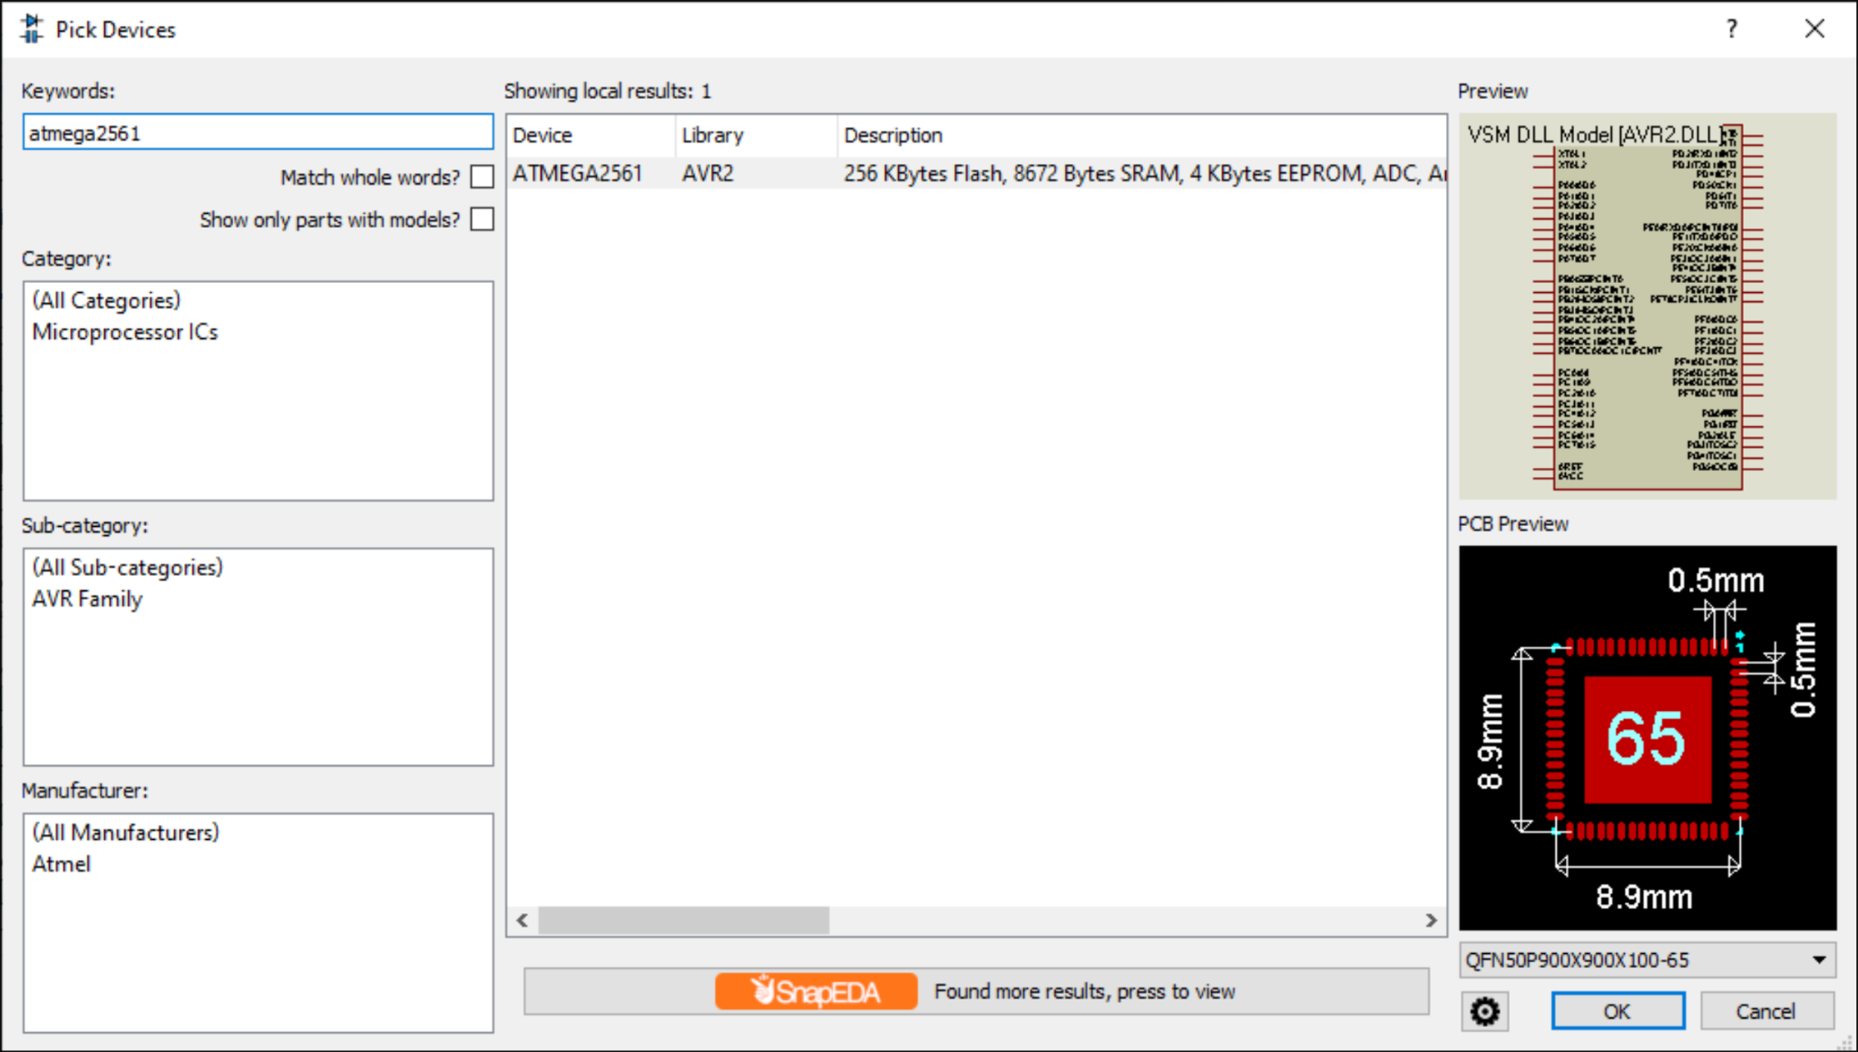
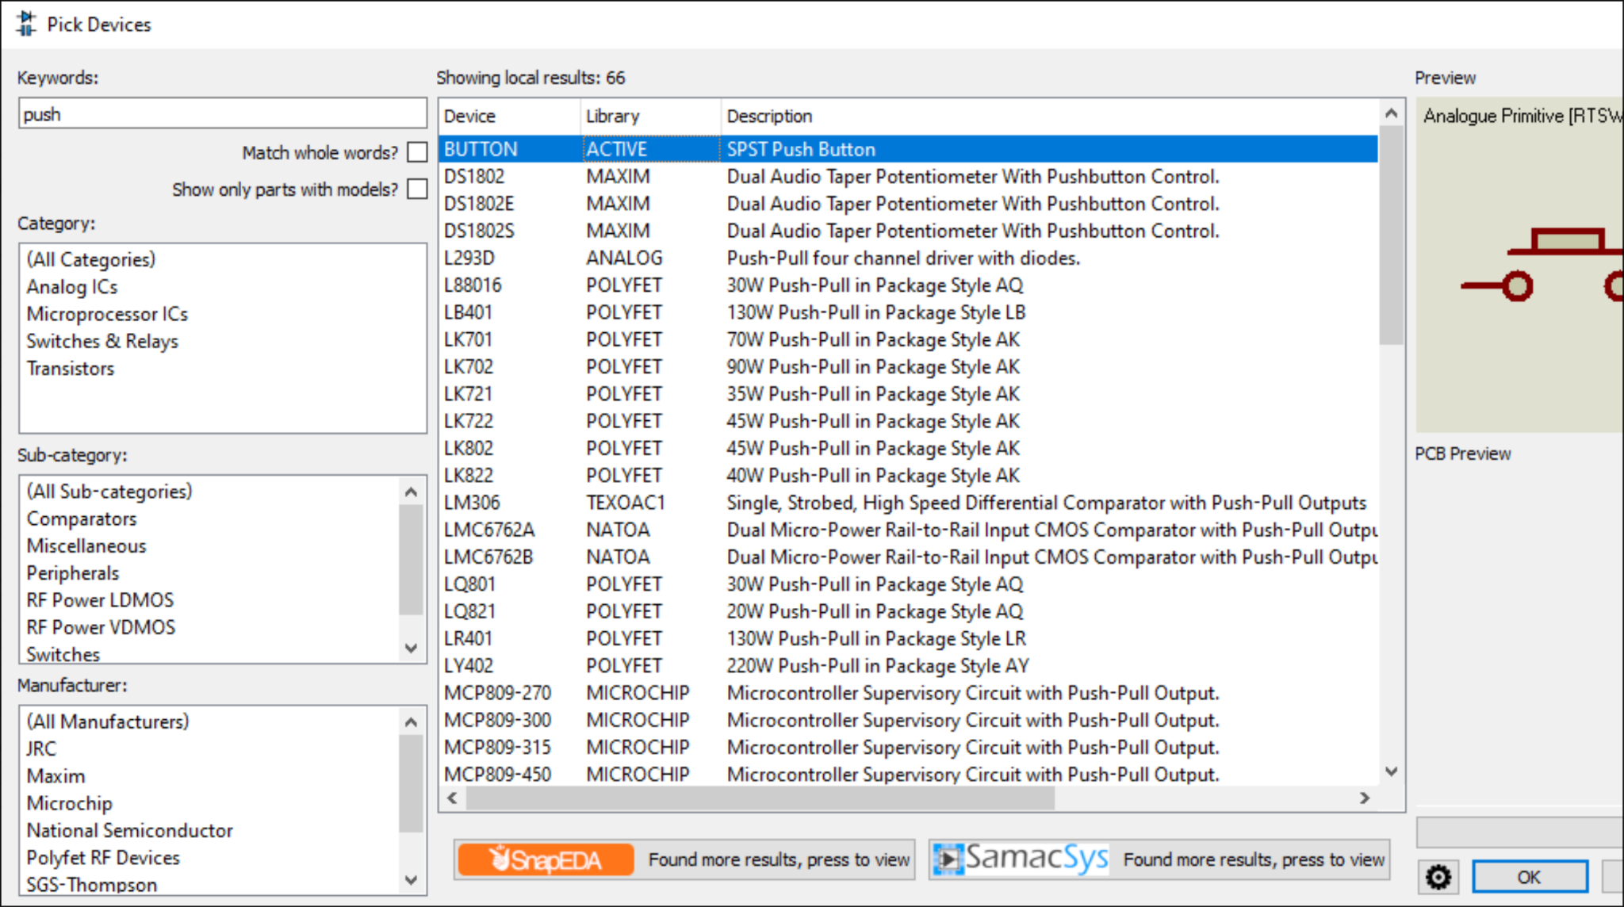

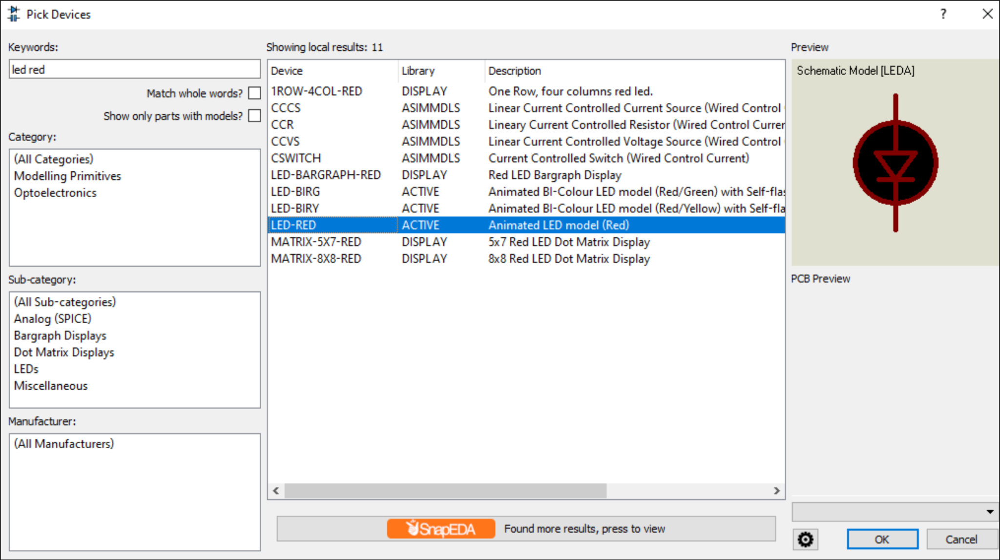
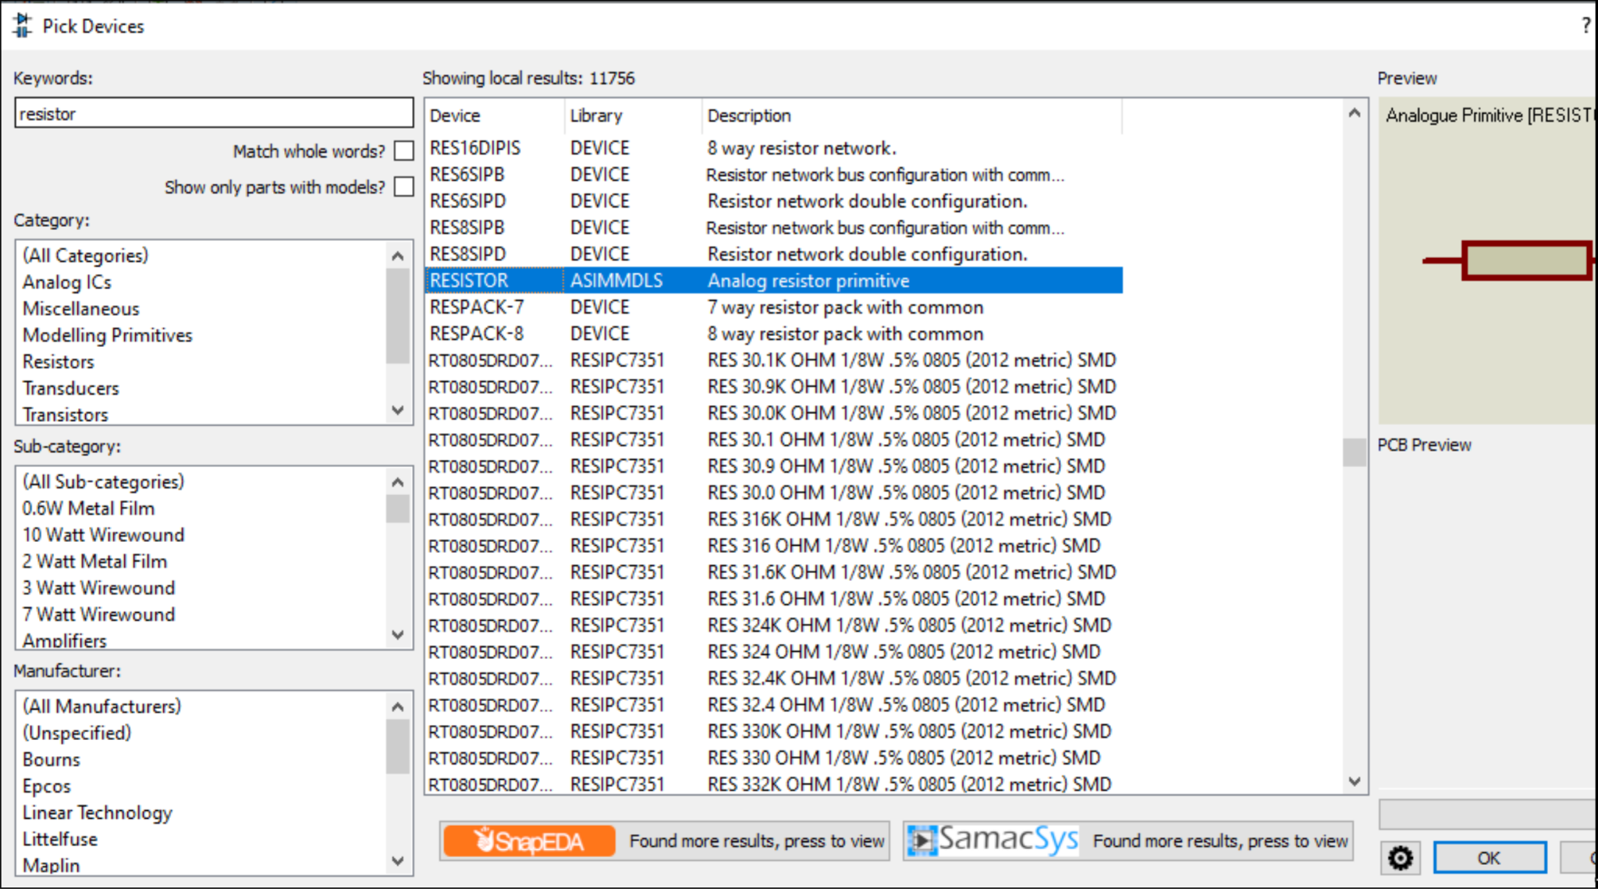

7. Load the compiled .hex file into the microcontroller's properties (Program File) and
configure the component
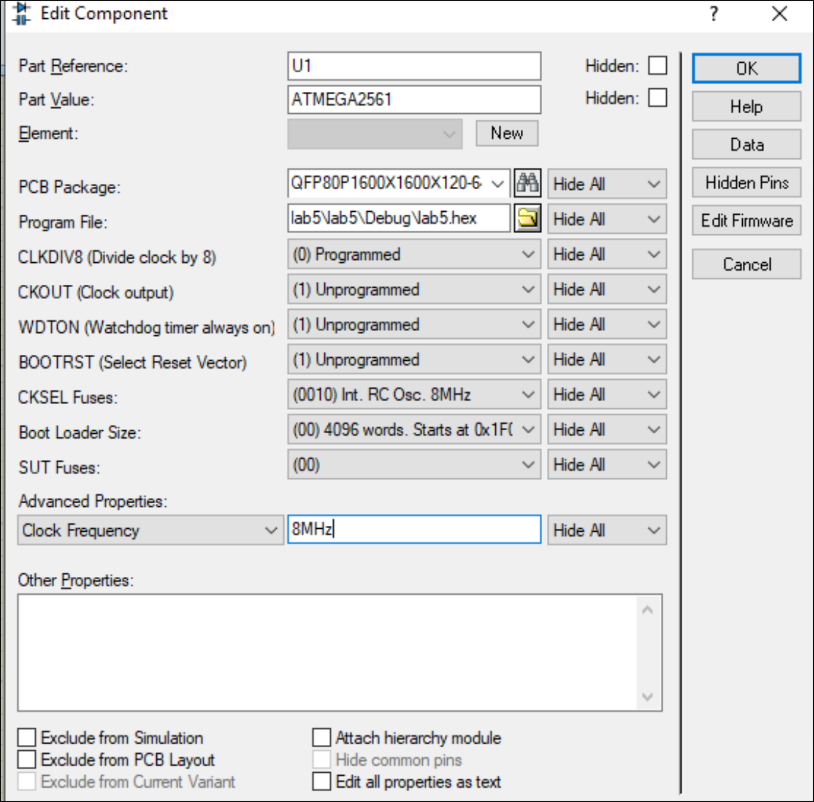
8. Run the simulation and verify that pressing the button triggers the INT0 interrupt and turns on the LED. The LED should remain on after you release the button.
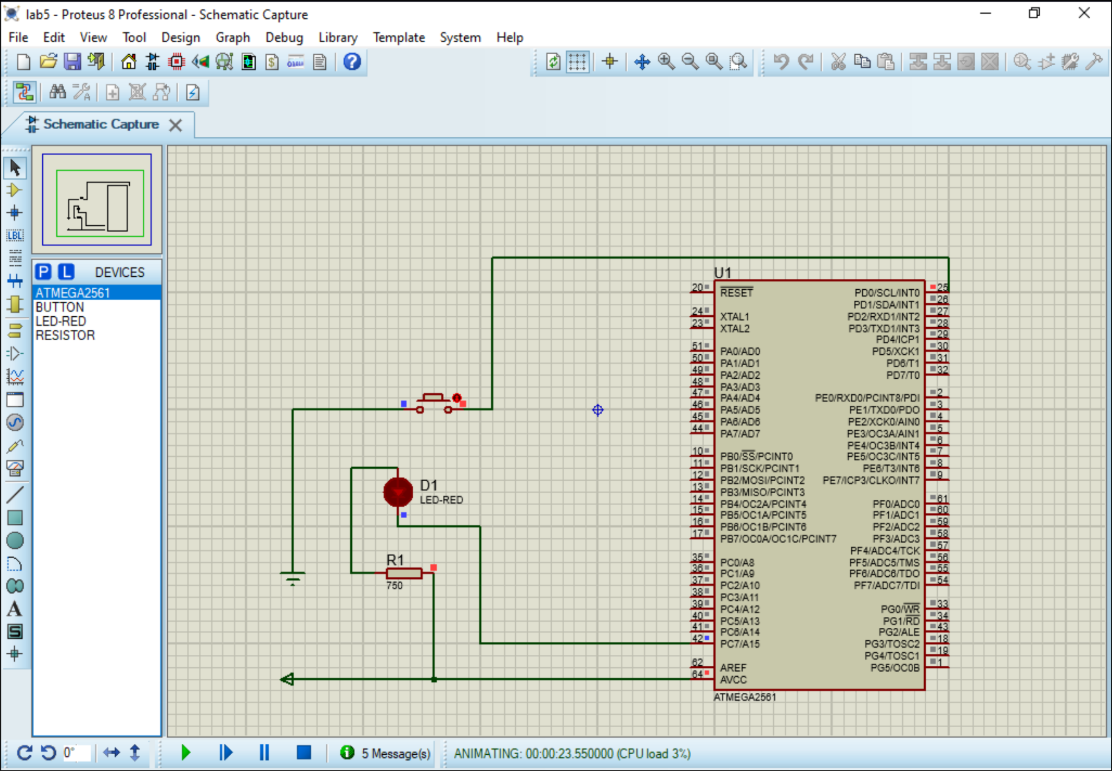
Conclusion:
In this laboratory work, I programmed the ATmega2561 to respond to a button press using an external interrupt. When the button is pressed, the interrupt routine turns on the LED. The LED stays on after the button is released, showing that the interrupt was triggered.

